SOUTH MOUNTAIN BAPTIST CAMP
OUTDOOR EDUCATION PROGRAM
Phone: 828-437-8788
3558 BAPTIST CAMP ROAD
CONNELLY SPRINGS, NC
28612

School Information
*School Name: _____________________________________________
*Phone: _____-_____-_________
*Mailing Address: __________________________________________ City: ________________________ State: _____ Zip: ____________

Contact Information
*Contact Name: ____________________________________________ *Position: ___________________
*Phone: _____-_____-_________
*E-Mail Address: _________________________________

Grade Level
3rd____ 4th_____ 5th_____ 6th_____ 7th_____ 8th _____ Other______

Class Size
*Number of Students: _____ *Number of Chaperones: _____

Trip Date (Best to call to ensure availability)
**Fall season is Mondays-Wednesdays from Sept. 4th to Nov. 2nd 2018**
**Spring season is Mondays-Wednesdays from March 4th-May 10th 2019**
*Desired Date: _____________

Trip Time
9AM-1PM_____ 10AM-2PM_____ Other Specified Time_______

Outdoor Education Trip Content Coverage
**Content presented below is based on the North Carolina Essential Standards. Please refer to http://www.dpi.state.nc.us/ to see the specific essential standards and objectives that are presented below.**

Directions: Select all clarifying objectives of the North Carolina essential standards for your grade level that you wish to be covered.

GRADE 3
3.E.2.1:______ 3.E.2.2:_____ 3.L.2.1:_____ 3.L.2.2:_____

3.L.2.3:______ 3.L.2.4:_____

GRADE 4
4.P.2.3:______ 4.E.2.3:_____ 4.L.1.1:_____ 4.L.1.4:_____

GRADE 5
5.P.2.1:______ 5.L.2.1:_____ 5.L.2.2:_____ 5.L.2.3:_____

GRADE 6
6.E.2.1:______ 6.E.2.2:_____ 6.E.2.3:_____ 6.E.2.4:_____

6.L.1.1:______ 6.L.1.2:_____ 6.L.2.1:_____ 6.L.2.2:_____

6.L.2.3:______

GRADE 7
7.E.1.6:_____ 7.L.2.3:_____

GRADE 8
8.P.2.2:______ 8.E.1.3:_____ 8.E.1.4:_____ 8.E.2.1:_____

8.L.3.1:______ 8.L.3.2:_____ 8.L.3.3:_____ 8.L.4.2:_____

STEPS TO TAKE PRIOR TO ARRIVAL
- Contact South Mountain Baptist Camp at 828-437-8788 to check on availability of your desired date to attend.
- Once you have ensured your available date, fill out the above forms and return them to camp at least 2 weeks prior to your attending date by either:
(1) E-mailing them to sara@smbc.camp OR
(2) Mailing them to:
Attention: Sara Cromer
3558 Baptist Camp Road
Connelly Springs, NC
28612
- Send home our release form to your students. This form is necessary to be filled out for the safety of your students. It also gives parents the option of allowing us to take photos of their child for future promotional use. This form is attached to this packet.
- Collect money from your students. The fee is $10 per student. Checks can be made payable to South Mountain Baptist Camp.

STEPS TO TAKE UPON ARRIVAL
- Follow designated signs to the Chapel (this will be where the program will begin). A map of the camp is attached. All buses/cars/vehicles should park in the Chapel parking lot.
- Have students enter Chapel and sit in the pews towards the front of the building.
- Turn in money to a South Mountain Baptist Camp employee (individuals will be wearing marked name tags).
- Enjoy your time! You work hard all school year long, so enjoy your day where the classroom is turned over to somebody else!

QUICK ANSWERS TO COMMON QUESTIONS
What do the students eat for lunch?
Please plan to have parents and/or the school cafeteria to provide lunches for your students. Students will be able to eat lunch in our dining hall while attending the program for the day.

Who will be leading this program?
Your leaders will be members of the staff here at South Mountain Baptist Camp. Your primary teacher will be Sara Cromer. Sara is a 2015 graduate of the University of North Carolina at Chapel Hill. While there, she studied Biology and Public Policy and obtained a minor in Chemistry. Sara taught 8th grade science at Southeast Middle School in Rowan County for a year before coming onto the full-time staff here at SMBC. Sara will be assisted by her husband, Ethan Cromer. He is a 2015 graduate of Western Carolina University, where he studied English Education. Ethan taught high school English for a year at East Rutherford High School in Rutherford County before working full-time at SMBC. They will both be assisted by part-time SMBC staff members throughout the program.

What should my students wear?
Students will be spending time both indoors and outdoors. While outdoors, they will be walking around the camp, which is very hilly. Students should make sure they are wearing shoes that they feel comfortable walking in.

What if it rains on the day that our group is scheduled to attend?
Since a large part of the program takes place outside, we suggest rescheduling your trip if rain is expected to be heavy during the day. If rain is not expected to be heavy, we will be more than happy to still hold your program for you. If you feel more comfortable rescheduling, we will be happy to provide another date that works well for you group. Please be in contact with us beforehand if you have plans of rescheduling.

How do I get to South Mountain Baptist Camp?
The official address of the camp is:
3558 Baptist Camp Road
Connelly Springs, NC
28612

Directions from different areas are:
**From Hickory or Areas East of Hickory:
Get on I-40 West.
Take the Longview Exit #121, turn right.
Go about 4 miles to the Advent Crossroads.
Veer right onto George Hildebran Road.
Go 7 miles to the stop sign and turn right at the Citgo.
Take an immediate left onto Sugar Loaf Road.
Follow Sugar Loaf Road until it ends at Old NC 18.
Turn left and go 1 mile.
Turn right onto Baptist Camp Road and follow it to camp,
which will be on your left.

**From Charlotte or Gastonia:
Take I-85 South to Hwy 321 North.
Stay on Hwy 321 to Lincolnton.
Exit onto Hwy 27 in Lincolnton.
Take Hwy 27 West until it intersects NC 18.
Turn right on NC 18 toward Morganton,
go 2 miles North to Old NC 18 (just past Webb’s Orchard Stand).
Turn left onto Old NC 18 and go 7 miles.
Turn left onto Baptist Camp Road, and follow it to the camp,
which will be on your left.

**From Asheville or Areas West of Morganton:
Get on I-40 East.
Take the Enola Road exit #104, turn right off the exit.
Go until Enola Road ends at Old NC 18 and turn right.
Go approximately 4 miles to the South Mountain Baptist Camp sign.
Turn right onto Baptist Camp Road and follow the road to camp,
which will be on your left.

**From Shelby:
Follow NC 18 until you come to Old NC 18.
Follow the directions above.

Camp Map
Note: Not to scale, hilly terrain.
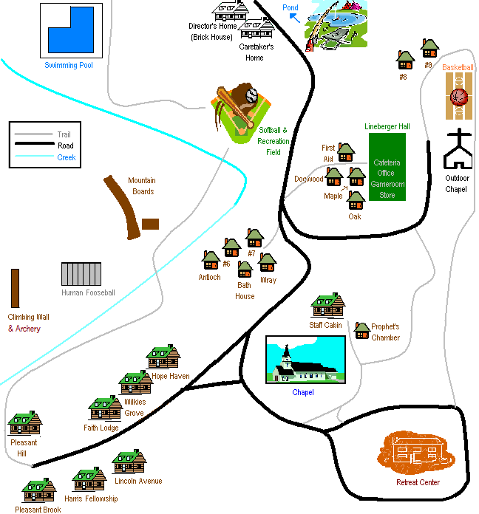

South Mountain Baptist Camp Release Form
Student Information
-Student Name: __________________________________________________________
-Birthdate: _______-_______-_______
-Mailing Address: ______________________________________________________
-Emergency Contact: ___________________________ Relationship: ___________________
- Primary Phone Number: _____-______-________
-Alternate Phone Number: ______-______-_______

Medical Information
Health Problems/Activity Restrictions: _____________________________________________________________________
Allergies (include drug allergies):____________________________________________________
Medications (must be in chaperone’s possession): _________________________________________________________

Release
It is mandatory that this form be completed, signed and dated by a legally responsible parent/guardian.
1. I, the undersigned, hereby give permission for the child listed on this form to attend the outdoor education day at South Mountain Baptist Camp. I agree to hold harmless South Mountain Baptist Camp or its agents for any and all claims for injuries, illnesses, causes of action, the rendering of emergency care, or liability related to participation in any activities. I give permission for this child to participate in all activities related to the outdoor education program for the day.
2. I, the undersigned, understand that if medical treatment is required, every effort will be made to contact me. In the event that I cannot be reached in an emergency and my child requires treatment, I hereby give permission to the physician selected by the camp administration to hospitalize, secure proper treatment for, and to order injection, anesthesia or surgery for my child, as named on this registration form.
3. I give permission to South Mountain Baptist Camp and Christian Camping & Conference Association to photograph and/or video tape my child for use in any future promotional material.
-Child’s Name: ________________________________________________________
- Date: ______-______-______
-Parent/Guardian’s Name: _________________________________Relationship: ______________
-Parent/Guardian’s Signature: _________________________________________________________

